# 1. Introduction

### 1.1 Purpose

The purpose of this software design document is to fully describe the architecture of the Enterprise Pro Task Management system. This web-based system is designed for the Yorkshire and Humber Regional Organised Crime Unit (YHROCU) support department to manage non-crime related tasks. The system will enable the assignment, tracking, and reporting of both individual and collaborative tasks, ensuring timely notifications and robust audit trails. This document serves as a blueprint for developers, stakeholders, and future maintainers.

### 1.2 Overview

This document outlines the following key areas:

**Architectural Design:** The overall structure of the system using a 3-tier architecture.

**Software Design Requirements:** A detailed list of functional and non-functional requirements, including task management, notifications, and user access controls.

**Data Description:** A description of the database tables and configurations used for managing users, tasks, projects, assigned tasks, task updates and users in projects.

**System Architecture:** An in-depth look at the system layers and component decomposition, supported by diagrams.

**Conclusion:** A summary of the design and its alignment with the departmental objectives.

## 2. Software Design Requirements

The Workflow Management System must meet the following requirements:

**Task Assignment and Notification:**

Enable tasks to be assigned to one or more staff members.

Automatically email the assigned staff member(s) when a task is allocated.

**Task Update and Logging:**

Allow users to update task status, and input progress updates to a rolling log.

Prevent staff from deleting a task or any previous update entries to preserve the historical record.

**Access Control and Supervisory Functions:**

Provide supervisory access to view all tasks, with options to restrict visibility to only the assigned persons or to all users. Allow a supervisor to close or delete a task as needed.

**Dashboard and Reporting:**

Offer a dashboard that categorizes and summarizes tasks, featuring filters such as status and due date. Include an export function to generate reports in CSV or PDF formats.

**System Flexibility and Search:**

Design with built-in flexibility to allow the addition of new data fields to tasks to support future changes. Implement a robust search function for efficient task retrieval.

**User Authentication:**

Implement user authentication using OpenAuth or a similar protocol to ensure compatibility with existing infrastructure and secure system access. This is an optional requirement.

## 3. Data Description

The system will interact with the following database tables to manage tasks and staff information:

**Users table:**

This table contains records of all staff members, including usernames, passwords, roles and team. It supports user authentication, retrieval and modification by admins.

**Tasks table:**

Stores task details such as task ID, title, details, status, due dates, and assigned dates. Each line represents a unique task.

**Task Updates table:**

Maintains a log of all updates made to tasks, including progress updates and status changes, ensuring a complete audit trail.

**Project Users table:**

This table contains records of all staff members and which projects they are part of.

**Projects table:**

Stores Project details such as Project ID, title, details, status, owners and review dates. Each line represents a unique project.

**Assigned tasks table:**

Maintains records of all tasks and the staff member(s) that they have been assigned to.

Figure 1: Database ER Diagram

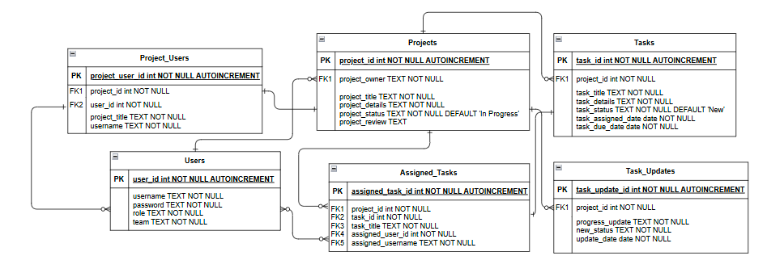

## 4. System Architecture

### 4.1 Architectural Design

The Workflow Management System is built using a 3-tier architecture:

**Client Layer (Blue):**

Provides a web-based interface where users, supervisors and administrators interact with the system. This layer is responsible for displaying dashboards, task forms, project overviews, progress logs, search functions and more.

**Application Layer (Green):**

Contains the business logic for task management, including assignment, update processing, notifications, and access control. It acts as the intermediary between the client interface and the database.

**Database Layer (Red):**

Manages persistent storage of all data, including user details, task records, and update logs. It ensures data integrity, security, and efficient retrieval.

Figure 2: 3-Tier Architecture System

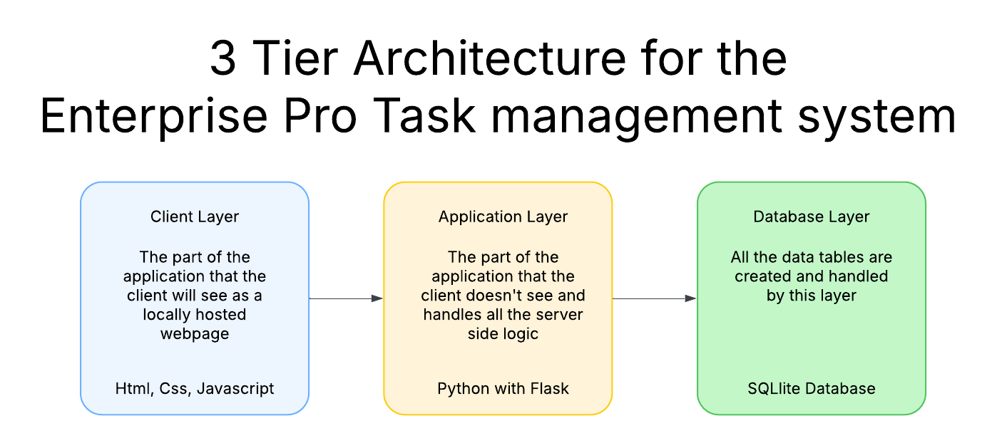

(Illustration: Client Interface → Application Logic → Database Storage)

**4.2 Decomposition Description**

The system is decomposed into several key modules:

**User Interface Manager:**

Manages the web interface, including dashboards, task forms, and search functionality. It handles real-time user interactions and displays task data.

**Notification Module:**

Automates email notifications to staff upon task assignment, ensuring timely alerts.

**Task Manager:**

Oversees task creation, assignment, status updates, and log management. It enforces rules to prevent unauthorized deletion of tasks or updates.

**Access Control and Authentication Module:**

Implements user authentication (using OpenAuth or similar) and enforces role-based access controls, differentiating between staff and supervisory functions.

**Reporting and Export Module:**

Provides analytics through a dashboard and supports data export in CSV or PDF formats.

**Database Manager:**

Interfaces for operations with the underlying database tables (Users, Projects, Tasks, TaskUpdates, AssignedTasks, ProjectUsers) to perform secure read/write operations while ensuring consistency.

Figure 3: Class Diagram:

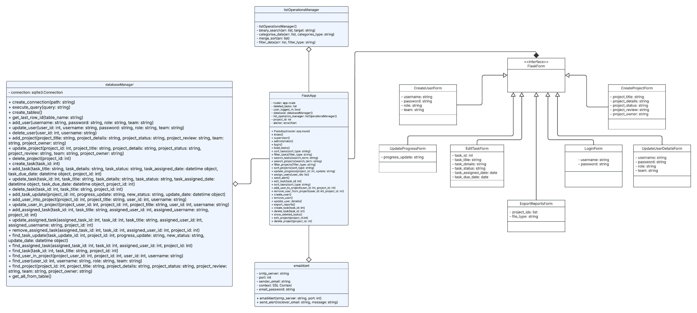

## 5. Conclusion

This Software Design Document outlines the comprehensive design of the Enterprise Pro Task Management system tailored for the YHROCU. Leveraging a robust 3-tier architecture and modular design, the system addresses key requirements such as automated notifications, secure access, detailed logging, and flexible task management. This design provides a strong foundation for improving operational efficiency and is well-prepared to accommodate future enhancements and changes. Feedback and further modifications are welcome to ensure that the final implementation meets all departmental objectives.